EXPERIMENT NO. 11
Online Super Market using Zoho Creator (SaaS)

Aim
To develop a cloud-based Online Super Market application using Zoho Creator to manage customer orders and demonstrate the Software as a Service (SaaS) cloud model.

Objective
• Create a cloud application for online supermarket management.
• Store customer and product details.
• Classify items into categories.
• Calculate the total amount based on quantity and price.
• Generate reports for customer orders.

Software Requirements
• Zoho Creator
• Google Chrome
• Internet Connection
• Deluge Script (optional)

Theory
The Online Super Market System is a cloud-based SaaS application developed using Zoho Creator. It stores customer information, purchased items, item categories, quantity, price and total amount. The application maintains records securely in the cloud and provides reports for viewing customer orders.

Fields Used
Customer Name, Address, Phone Number, Email, Item, Category, Quantity, Price and Total.

Algorithm
1. Start.
2. Open the Online Super Market form.
3. Enter customer details.
4. Enter item details.
5. Select item category.
6. Enter quantity and price.
7. Calculate total amount.
8. Save the record.
9. Generate report.
10. Stop.

Procedure
1. Login to Zoho Creator.
2. Create the Online Super Market application.
3. Design the form with required fields.
4. Add item classification fields.
5. Enter sample records.
6. Save the records.
7. Generate and verify the report.

Observation
The application accepted customer details successfully. Item classification, quantity, price and total amount were stored correctly. Reports displayed all customer purchase records, and the individual record view displayed complete order details. The SaaS application functioned successfully.

Result
The Online Super Market application was successfully developed using Zoho Creator. Customer order information was stored and reports were generated successfully.

Conclusion
The experiment successfully demonstrated a SaaS-based Online Super Market application using Zoho Creator.

Screenshots
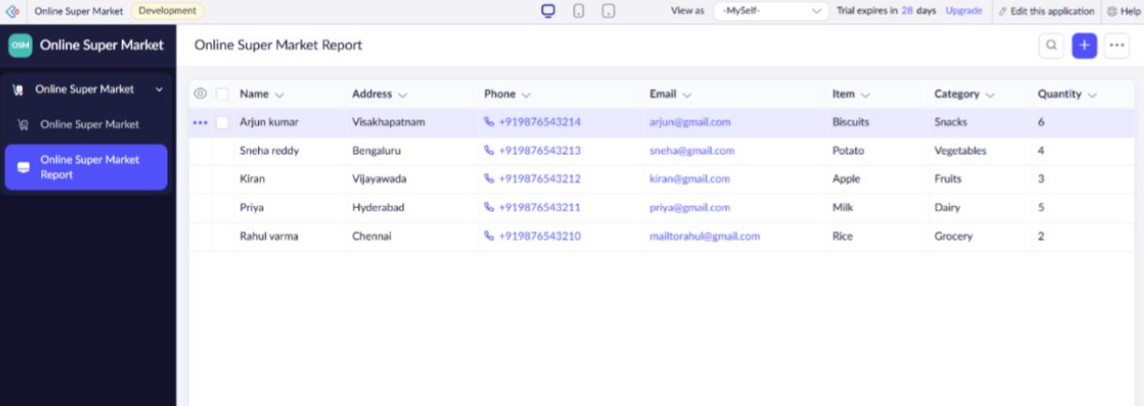
Figure 1: Online Super Market Entry Form
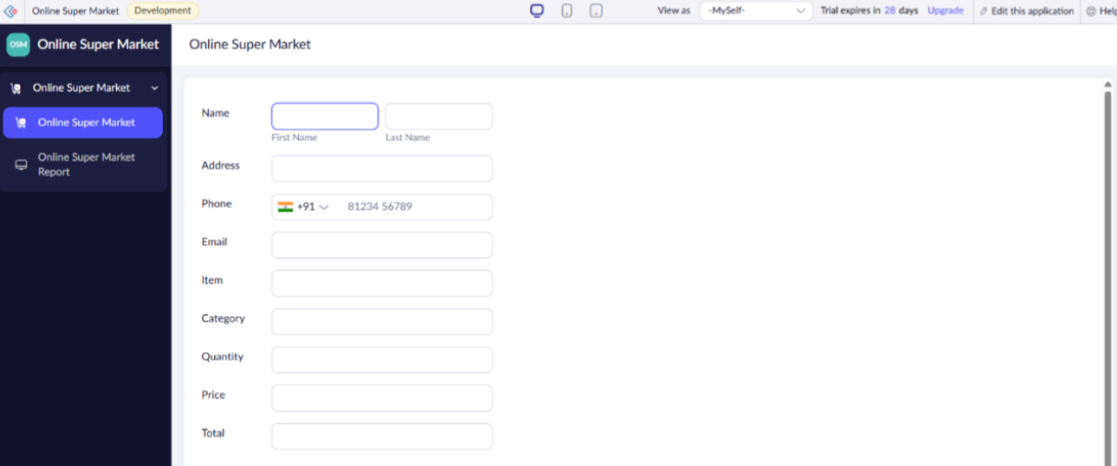
Figure 2: Online Super Market Report
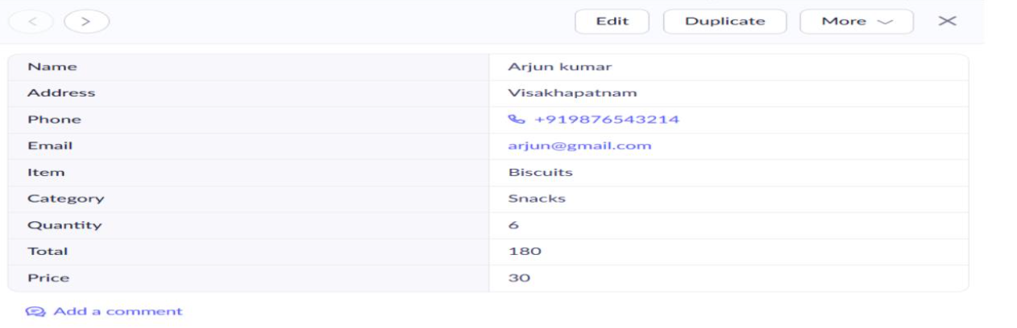
Figure 3: Individual Customer Order

